Kirsten Leslie, Biography

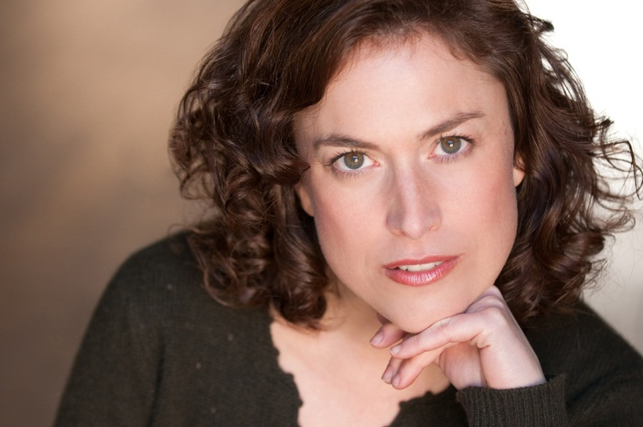
Kirsten Leslie, originally from the Chicago area has performed nationally and internationally as both singer and actress. Her repertoire is quite diverse: operatic roles such as Gilda in Rigoletto, the “Flier” (or Amelia Earhart) in Daron Hagen’s Amelia and Orquidea in Daniel Catan’s Salsipuedes; musical theatre roles such as Anne in A Little Night Music and Carrie in Carousel; and straight theatre roles such as Imogen in Shakespeare’s Cymbeline.

She gave her Carnegie Hall debut singing Mozart’s Exultate Jubilate, Vivaldi’s Gloria and John Rutter’s Magnificat conducted by the composer. She was asked to sing with Maestro Rutter once again at Carnegie Hall in the Messiah and his Magnificat. Miss Leslie soloed in a Carnegie Hall premiere performance of Rossini’s Ermione with well-known tenors, Barry Banks and Bruce Ford.

Opera performances include Madame Herz in Der Schauspieldirektor with Florentine Opera; Blondchen in Die Entfuhrung aus dem Serail ; Susanna in Le Nozze Di Figaro, Norina in Don Pasquale, Antonia in Les Contes D’Hoffmann; Morgana in Alcina; Polly from the Beggar’s Opera and Leila in The Pearl Fishers.
Oratorio solo performances include Israel in Egypt with the Houston Symphony last spring; Carmina Burana with the Pacific Symphony Orchestra, CA, conducted by Carl St. Clair; Mozart’s Coronation Mass with the Illinois Symphony; Vivaldi’s Gloria with the Apollo Chorus in Chicago; In Terra Pax by Gerald Finzi with the Elgin Symphony; Haydn’s Seasons, Mozart’s Davide Penitente, Bach’s Magnificat, Respighi’s Laud to the Nativity, Mozart’s Mass in c minor, Faure’s Requiem, Britten’s Ceremony of Carols, Schubert’s Mass in G, Mozart’s Missa Brevis, and Haydn’s Lord Nelson Mass.

Her extensive background in musical theatre includes such leads as Maria in West Side Story with Hunter Foster as Tony; Magnolia in Showboat with Michael Lackey as Ravenal; Luisa in the Fantastiks, and Young Sally in Sondheim’s Follies.
While employed with the Colonial Williamsburg Foundation, Miss Leslie developed the character of “Nancy Hallam”, an actual 18th century “triple threat” - singer/dancer/actor (and harpsichordist too). She was featured on the cover of the Colonial Williamsburg Journal along with an article about her research of Miss Hallam. She also played the leads in several 18th century plays including Steele’s The Tender Husband, Ryder’s The Provoked Wife and Rowe’s The Tragedy of Jane Shore.
She was “Artist in Residence” at Middlebury College’s prestigious Intensive Italian and German Study Programs. She received a scholarship to study at the University of Florence in Italy where she was “Visiting Artist”; and since, has performed in Italy often – most recently in Puglia where she won the “Padre Pio Sacred Music Competition” in San Giovanni Rotondo.

A member of Actor’s Equity Association (as well as SAG and AGMA), Miss Leslie played Anabella in the musical production of “A Christmas Carol” at Westport Playhouse directed by Tazewell Thompson, famed stage director for various productions of theatre and opera around the world including the New York City Opera and Opera Bastille in Paris.
Miss Leslie was a Metropolitan Opera Competition District Winner; and has toured as a soloist throughout Italy, Holland, Austria, Germany and the Czech Republic. She is currently finishing up a graduate degree in Vocal Pedagogy/Performance at the Moores School of Music at the University of Houston.

